**GCC Assignment**

1. Logging into linux server

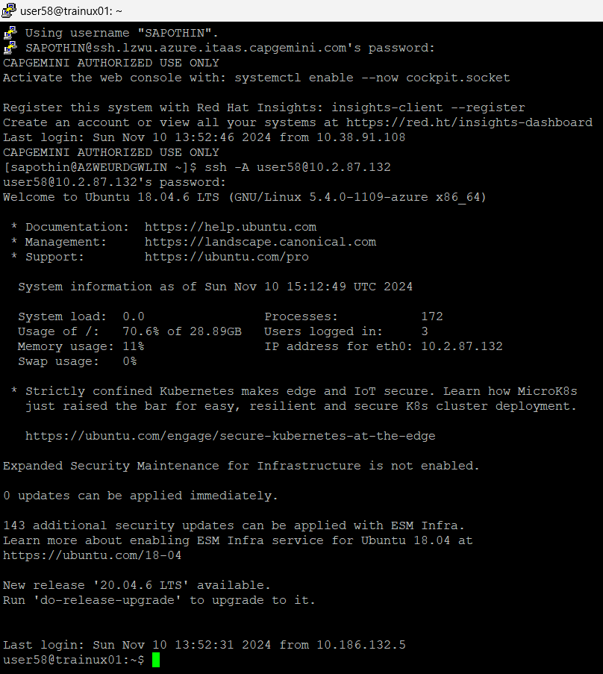

1. To compile code “gcc code.c” command is used.

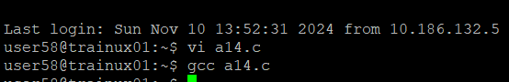

1. To execute the file “./a.out” command is used

|  |  |
| --- | --- |
| Executable Files | Object Files |
| This is the final output of the  compilation, and it can be executed  directly. | This is an intermediate file generated from the source code and is not executable by itself. It contains compiled code but lacks the full linking. |

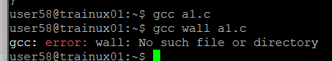

1. A computer screen with white text

   Description automatically generated
2. A screen shot of a computer screen

   Description automatically generated

